**Using the Installation DVD for an Image Restore**

**Time Required:** Approximately 10 minutes

**Objective:** Learn from where to perform an image restore.

**Description:** In this activity, you learn how to access the Repair option from a Windows Server 2016 installation DVD and how to use it to start an image restore. You will need

the Windows Server 2016 installation DVD (or thumb drive). You do not need an image

backup, because you simply learn from where to start it. Note that your computer’s BIOS

should also be set to try to boot first from the medium you use, such as an optical drive

(see Chapter 2, Installing Windows Server 2016, and refer to Activity 2-1). Alternatively, on

a virtual machine, your system should be able to recognize the installation medium, such as a

DVD in an optical drive.

1. Insert the Windows Server 2016 installation DVD or a bootable Windows Server 2016 installation thumb drive.
2. Right-click the **Start** button, point to **Shut down** or **sign out**, and click **Restart**.
3. When the computer reboots, press Enter or another key at the message or prompt to key to boot from a CD or DVD or thumb drive (or on a virtual machine, you may just blinking prompt, which implies that if you press a key it will start from the removable age medium, such as a DVD).
4. Press **Next** in the Windows Setup window to configure the language, time and current keyboard or input method options.
5. In the Windows Setup window with the Install now button, click Repair your **computer**.
6. On the Choose an option screen, click **Troubleshoot**.

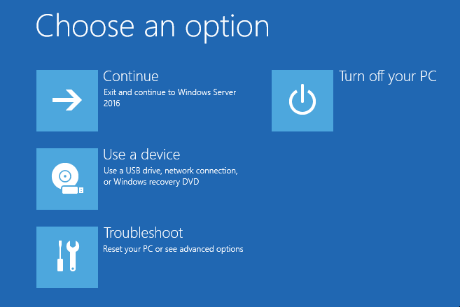

1. On the Advanced options screen, click **System Image Recovery**.

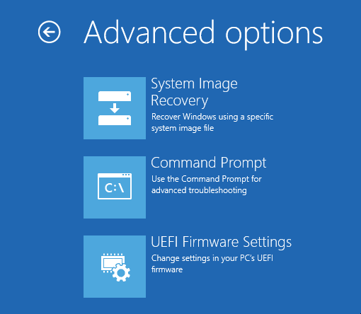

1. On the System Image Recovery screen, click the appropriate operating system (a computer can have more than one operating system installed).
2. If you see an error message box that Windows cannot find a system image, click **Cancel**.
3. In the Select a system image backup dialog box, you can specify the image or image location. To actually start the backup you would click Next and complete the guided steps to start the backup. However, do not perform an image backups this time.

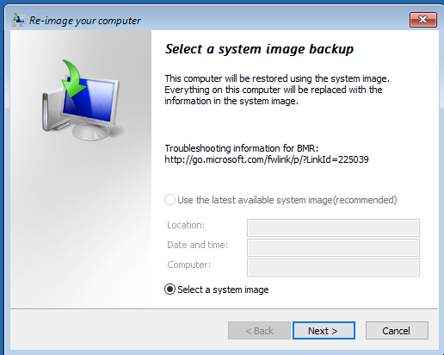

1. Click **Cancel**.
2. Leave the Choose an option screen open for the next activity. (Or if you have to stop no select the Turn off your PC option.)